CURRICULUM VITAE
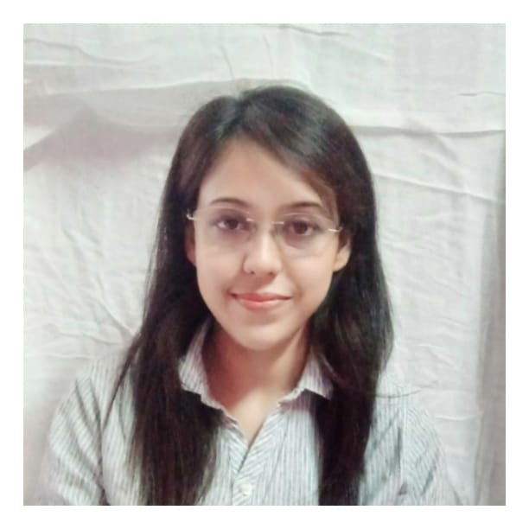
Name : PRAJNA BORAH
Current Address : Guwahati
Contact No. : 9706222738

E-mail Address : prajnaborah2014@gmail.com / pborah@rgu.ac
Websites : https://cotton.academia.edu/Prajna Borah
Languages Known : Assamese, English, Hindi, Sanskrit

Academic Experiences:
- Worked as a Research Associate at the Social Science Research Institute, OKDISCD (Omeo Kumar Das Institute of Social Change and Development, VIP Road, Guwahati.) Served as Research Associate in a project entitled “Status, Bureaucracy and Materialism : A Case of Stratification in Satra in Weberian View” in Omeo Kumar Das Institute of Social Change and Development (OKDISCD), Guwahati
- Post Graduate Ceriticate Programme on North-East India, in Omeo Kumar Das Institute of Social Change and Development (2017). Result issued by Dibrugarh University (First Class with 66%)

- Worked as an Assistant Professor in the University of Science and Technology Meghalaya (USTM) in the Department of Sociology from the year 2018 to 2019.
- Engagement with KKHSOU (Krishna Kanta Handiqui State Open University) for writing Students Learning Materials (SLM) of their course.
- Environmental Sociology- 2 chapters for master degree
- Demography – 6 chapters for masters
- Engagement with Tezpur University, CODL (Center for Open Distance Learning) for writing SLM of masters.
- Environmental Sociology- 7 chapters for masters
- Industrial sociology- 6 chapters for masters

- Engagement with KKHSOU, Gauhati, for Examination question Paper Setting (Masters Students).
- Pursuing Ph.D (Cotton University, Department of Sociology, 2020- present)

Primary Teaching Area:
Sociological Theories, Economic Sociology, Gerontology

Ph.D Research Area: Tribal Studies and Minority Rights

Research papers and Academic Activities:
1. Attended two days National Seminar on Impact of Positive Discrimination in Assam With Special Reference to Scheduled Caste Groups organized by Gauhati Univeristy in collaboration with ICSSR- North east regional Center, Shillong (4-5th November, 2014). Presented a paper, viz, Neo-Vaishnavite Movement and Caste in that National Seminar.

2. Presented a paper on ‘Structural expression of Bureaucracy and Status in Satras in the Light of Weberian and Marxist terms ’ in two days National Seminar on the theme Srimanta Sankardeva and His Times organized by Assamese Language Unit, Visva Bharati University, Shantiniketan, West Bengal.

3. Submitted a paper on ‘Habitus of Power of Assamese Language in Constructing Women in Pierre Bourdieu’s understanding’ in an National journal Manavayatan, the Humanosphere.

4. Attended Five-day-Short Term Capacity Building Programme in Social Science Research organized by Omeo Kumar Das Institute of Social Change & Development during 9-13 January, 2017
5. Presented a paper in two day National Seminar on Minority Rights and Gender Justice in India: A Qualitative Discussion on Academic and Social Policy organized by University of science and Technology, Meghalya in ollaboration with RC 10 (Gender Studies) and RC 26 (Minority Studies) of Indian Sociological Society (2022), entitled “Locating Women in Land Alienation Process: A Study on Adivasi Women in Mikir Bamuni Grant Village, Nagaon”.

- Presented a paper in the 47th All India Sociological Conference (thee day International conference) under the ad hoc Research Committee 29 (2022, Indian Sociological Society) entitled “Bifurcated Consciousness and Digital Divide: A Subaltern Perspective towards Digital Society”.

- Submitted a book chapter entitled “Representation of Self in Cyberspace: A Gendered Response to Culture Industry” to the book Media and Society, Routledge, India.

- Attended two day International Online Conference (21st-22nd April, 2020) on Teaching-Learning in the Time of Pandemic: Role of Online Learning, Organized by Krishna Kanta Handiqui State Open University, Gauhati, Assam in collaboration with Commonwealth Education and Media Center for Asia (CEMCA).

Professional Membership:
1. Life Member of Indian Sociological society (Membership No. LM5341)
2. Executive Member of Digital Sociology (Adhoc RC Group 01,Indian Sociological Society)

Training Programmes and FDPs:
- Training Programme on Labour and Globalization by VV Giri National labour Institute, Noida (Online, 20th July to 22nd July, 2020).
- Online Lecture Series on “Populism and Deterred Democracy” by Noam Chomsky, organized by IIT Roorkee, August 2022.
- E-FDP on “Importance of Cross-Disciplinary Research in the Post-Covid-19Scenario: Social Perspectives” (16th-23rd June, 2020)
- E-FDP on “New Narrative of NAAC” organized by RR Institute of Advanced Studies, Bangalore (1st-7th August, 2020)

Other Proficiency:
1. Second Position in All Assam Art Competition, organized by Janambhumi Group, Year 2004.
2. Completed Course on Computerized Publishing, Computer Fundamentals from APTECH Computer Education, Nagaon Branch (APTECH House, A-65, MIDC, Marol, Andheri (E), Mumbai-400093, India, 2009.
3. Completed Advanced Art from Kallol School of Drawing and Painting, Nagaon (1997-2007).

The above statements are true to the best of my knowledge.

Prajna Borah
Dated: 18/02/2023

